**­­­­­­­­­­­­­FRONT END ENGINEERING-II**

Project Report­­

Semester-IV(Batch-2022)

Dicet Tv

**Supervised By: Submitted By:**

Mrs. Sheena Angra Shivansh Sharma

2210990833

Group:-G13

**Department of Computer Science and Engineering**

**Chitkara University Institute of Engineering & Technology, Chitkara University, Punja**

**Table Of Content**

|  |  |  |
| --- | --- | --- |
| **Sr No.** | **Section** | **Page No.** |
| **1.** | Introduction | 4 |
| **2.** | Problem Statement | 5 |
| **3.** | Technical Details | 7 |
| **4.** | File Structure | 8 |
| **5.** | Result | 9 |
| **6.** | References | 22 |

Introduction

Background

In the rapidly evolving digital landscape, the need for efficient and user-friendly web solutions has become paramount. The advent of web technologies has transformed the way businesses operate, offering unparalleled opportunities for growth and innovation. This project, titled "CREATIVES SERVIES," aims to develop a comprehensive and interactive web platform for a hypothetical company named " CREATIVES SERVIES." The platform is designed to showcase the company's services, engage with its audience through various content sections, and facilitate seamless communication and interaction.

In today's digital age, the internet serves as a crucial platform for learning and development. The accessibility of online educational resources has revolutionized the way people acquire new skills and knowledge. There is a growing demand for high-quality, easily accessible tutorials across a wide range of subjects. Traditional education systems often face limitations in terms of resources, accessibility, and flexibility, making online platforms an essential supplement or alternative. By creating a web page dedicated to providing tutorials in various fields, this project aims to bridge the gap between learners and educational content, ensuring that individuals have the opportunity to learn at their own pace and according to their specific interests

Objectives

The primary objectives of the " CREATIVES SERVIES " project are as follows:

* To establish a strong online presence: The project aims to create a visually appealing and functional website that effectively represents the company's brand and values.
* To enhance user engagement: By incorporating interactive elements and engaging content, the website aims to attract and retain users, thereby fostering a strong community around the brand.
* To facilitate easy navigation: The website is designed with a user-friendly interface, ensuring that users can easily navigate through different sections of the site to find the information they need.
* To provide comprehensive information about the company and its services: The website will serve as a digital hub for all things related to CREATIVES SERVIES, offering detailed information about the company's offerings, testimonials, and contact information.
* To support the company's marketing and communication strategies: The website will be utilized as a tool for marketing, promoting the company's
* products or services, and communicating with its audience.
* The primary objective of this project is to develop a comprehensive web page that offers tutorials across a multitude of disciplines. This platform aims to:
* Provide high-quality, user-friendly tutorials that cater to learners of all levels.
* Cover a wide range of subjects, including but not limited to technology, arts, science, languages, and personal development.
* Ensure that the content is accessible to a global audience, breaking down geographical and socio-economic barriers to education.
* Create an interactive and engaging learning environment that encourages continuous learning and skill development.
* Support learners with diverse learning preferences through various formats such as video tutorials, written guides, and interactive quizzes.

Significance

The development of the " CREATIVES SERVIES " holds significant importance for several reasons:

* Digital Transformation: In today's digital age, having a well-designed and functional website is crucial for any business. It not only enhances the company's online visibility but also plays a pivotal role in its digital transformation.
* Competitive Advantage: A well-designed website can give CREATIVES SERVIES a competitive edge by setting it apart from its competitors. It can attract more customers, increase brand awareness, and ultimately lead to business growth.
* Customer Engagement: By providing a platform for user interaction, the website can foster a stronger relationship with the company's audience, leading to increased customer loyalty and satisfaction.
* Brand Building: The website serves as a digital billboard for CREATIVES SERVIES, allowing the company to showcase its brand, values, and services in a compelling manner.

This project represents a significant step towards achieving these objectives and will play a crucial role in the company's digital strategy. Through the development of the " CREATIVES SERVIES," CREATIVES SERVIES aims to establish itself as a leader in its industry, providing high-quality services to its customers while maintaining a strong and positive online presence.

### Problem Definition

The problem at hand involves the development of a web-based platform, as outlined in the provided React code snippet. This platform appears to be a website for a company or service provider, offering various features and services to its users. The website includes sections for navigation, main content, services, testimonials, advertisements, a video section, and a footer with contact information and links to social media.

The primary challenge is to ensure that the website is functional, visually appealing, and user-friendly. It should be responsive, meaning it should adapt to different screen sizes and devices, ensuring a consistent user experience across platforms. Additionally, the website needs to be accessible, with proper alt text for images to support users with visual impairments.

### Requirements

#### **Software Requirements**

* **Web Development Tools**: HTML, CSS, and React are essential for building the website. HTML structures the content, CSS styles it, and React adds interactivity.
* **Responsive Design Tools**: To ensure the website is responsive, CSS frameworks like Bootstrap be used. These frameworks provide pre-designed components and utilities for responsive design.
* **Version Control System**: Git, hosted on platforms like GitHub or GitLab, is necessary for version control and collaboration among developers.
* **Content Management System (CMS)**: If the website needs to be updated frequently, a CMS like WordPress, used. This allows non-technical users to update content without needing to edit the code directly.

#### **Hardware Requirements**

* **Development Environment**: A computer with a stable internet connection, a modern web browser (e.g., Chrome, Firefox), and a code editor (e.g., Visual Studio Code, Sublime Text) is necessary for development.
* **Testing Devices**: To ensure the website is responsive and works across different devices, testing should be conducted on various screen sizes and devices, including desktops, tablets, and smartphones.

#### **Data Sets**

* **Content Data**: Text, images, and other media content that will be displayed on the website. This includes text for articles, descriptions of services, testimonials, and any other content that will be displayed to users.
* **User Data**: If the website includes features like user registration, login, or comments, a database will be needed to store user information and interactions. This could be a relational database like MySQL or PostgreSQL, or a NoSQL database like MongoDB, depending on the specific requirements.

### Conclusion

The development of this website involves a combination of front-end and requiring a mix of software tools and hardware resources. The website aims to provide a comprehensive online presence for a company or service, offering a wide range of features and services to its users. By addressing the problem definition and requirements outlined above, the website can be developed to meet its objectives effectively.

**Technical Details**

The front-end website for the design agency was constructed with a minimalist approach, employing only essential technologies to ensure a streamlined user experience. Here are the primary technical details of the project:

* **HTML Structure:** The website's structure was crafted using semantic HTML mark up to enhance accessibility and clarity. Each page was organized with appropriate tags to facilitate straightforward navigation and readability.
* **CSS Styling:** Cascading Style Sheets (CSS) were utilized for styling the website's layout, typography, and color schemes. Custom CSS rules were applied to maintain a consistent visual design across the site while optimizing load times and code simplicity.
* **Responsive Design:** Responsive design principles were implemented to ensure the website's compatibility with various devices and screen sizes. Media queries and flexible layouts were employed to adapt the content and design elements responsively without reliance on frameworks.
* **React.js** is a popular JavaScript library for building user interfaces, particularly for single-page applications where you need a fast and interactive user experience. Developed and maintained by Facebook, React allows developers to create large web applications that can update and render efficiently in response to changing data.

**FILE STRUCTURE**

**public/**

**index.html:** The main HTML file that serves as the entry point for the React application.

**favicon.ico:** The favicon for the application.

**manifest.json:** Configuration for the web app manifest, used in Progressive Web Apps (PWA).

**src/**

**assets/:** Contains static assets like images and stylesheets.

**images/:** A folder for storing image files.

**styles/:** A folder for global stylesheets or CSS files.

**components/:** Contains reusable UI components.

**App/:** The main application component. Typically includes the primary layout and routes.

**App.js:** The main component file.

**App.css:** Styles specific to the App component.

**App.test.js:** Test file for the App component.

**Header/:** Example of a header component.

**Header.js:** The header component file.

**Header.css:** Styles specific to the Header component.

**Footer/:** Example of a footer component.

**Footer.js:** The footer component file.

**Footer.css:** Styles specific to the Footer component.

**pages/:** Contains components that represent entire pages in the application.

**App.js**: The root component that includes the main layout and routing.

**index.js:** The entry point for the React application. It renders the App component into the DOM

**index.css**: Global styles for the application.

**Root Files**

**.gitignore:** Specifies which files and directories to ignore in version control.

**package.json:** Contains metadata about the project, including dependencies and scripts.

**README.md**: A readme file that provides an overview of the project.

**package-lock.json:** Lock file for npm/Yarn dependencies to ensure consistent

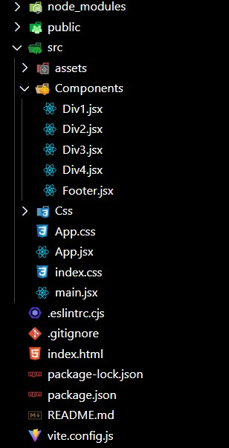

**Website Screenshots:-**

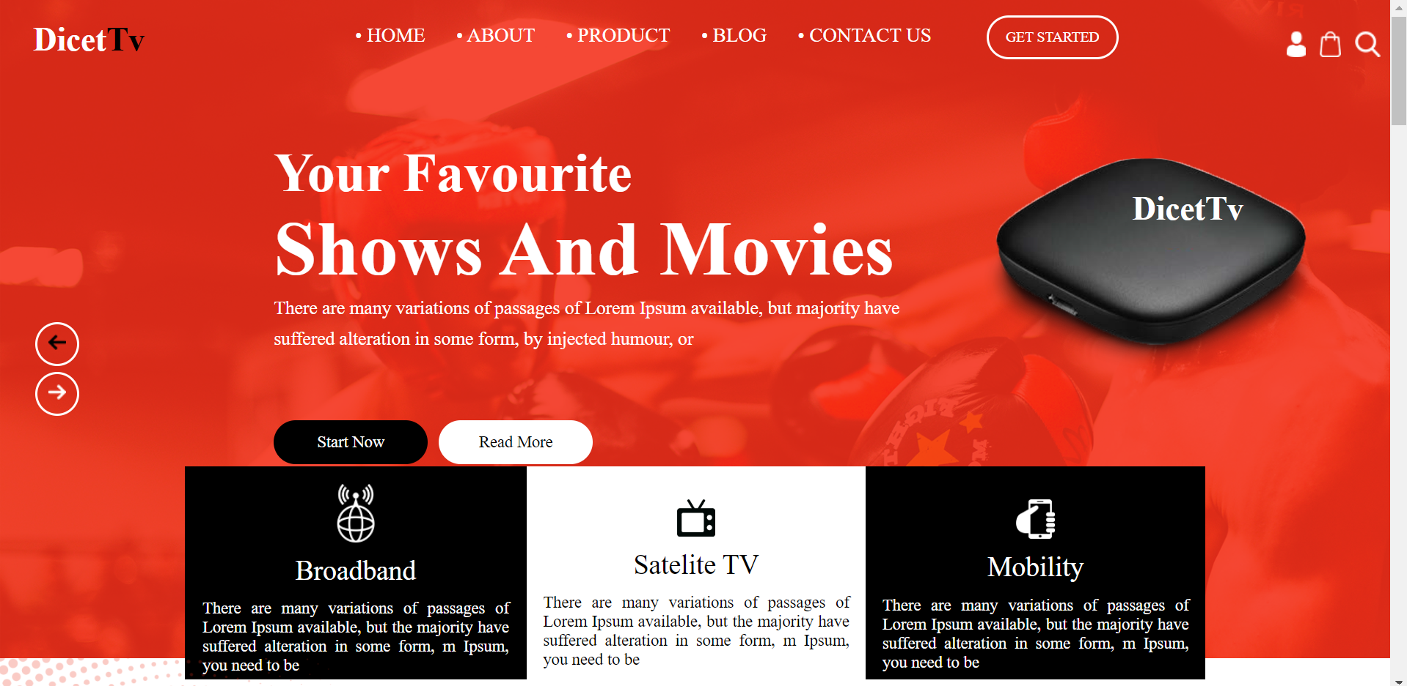

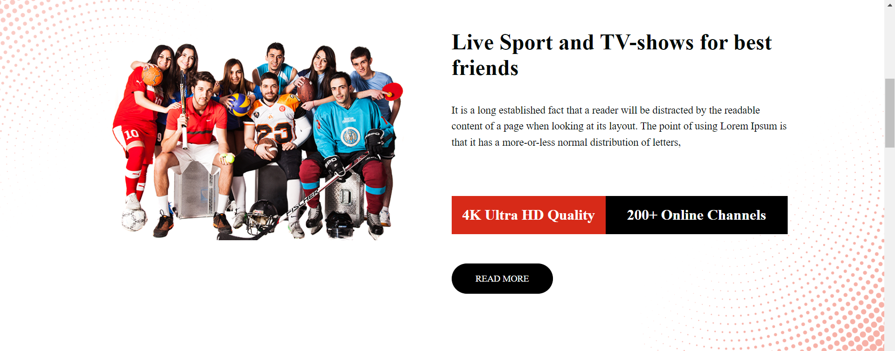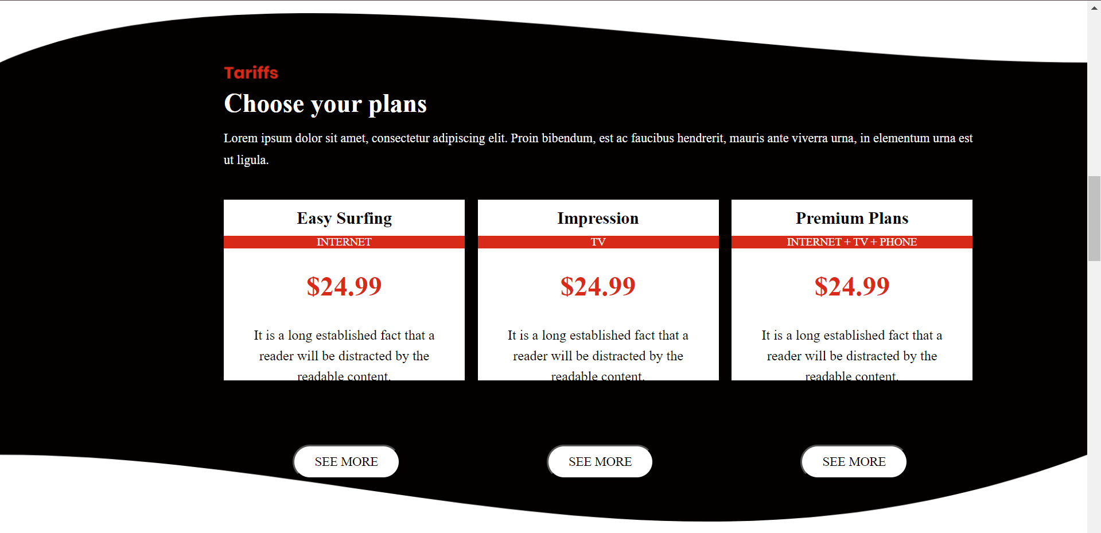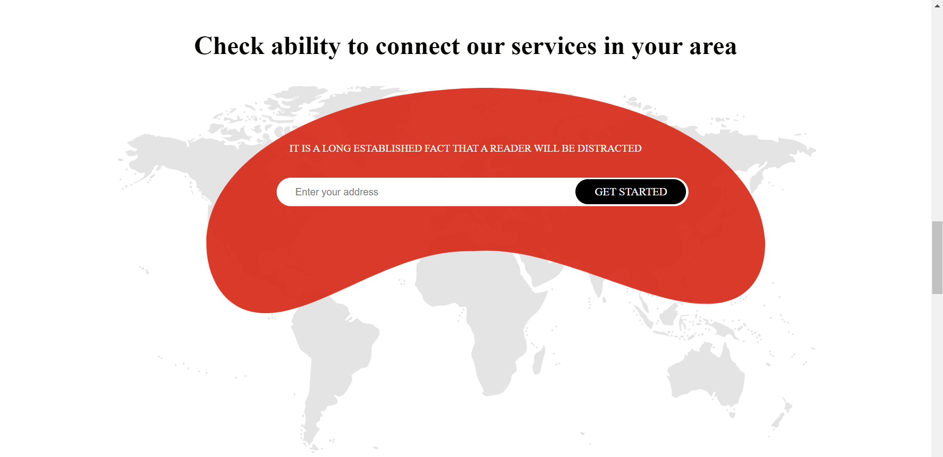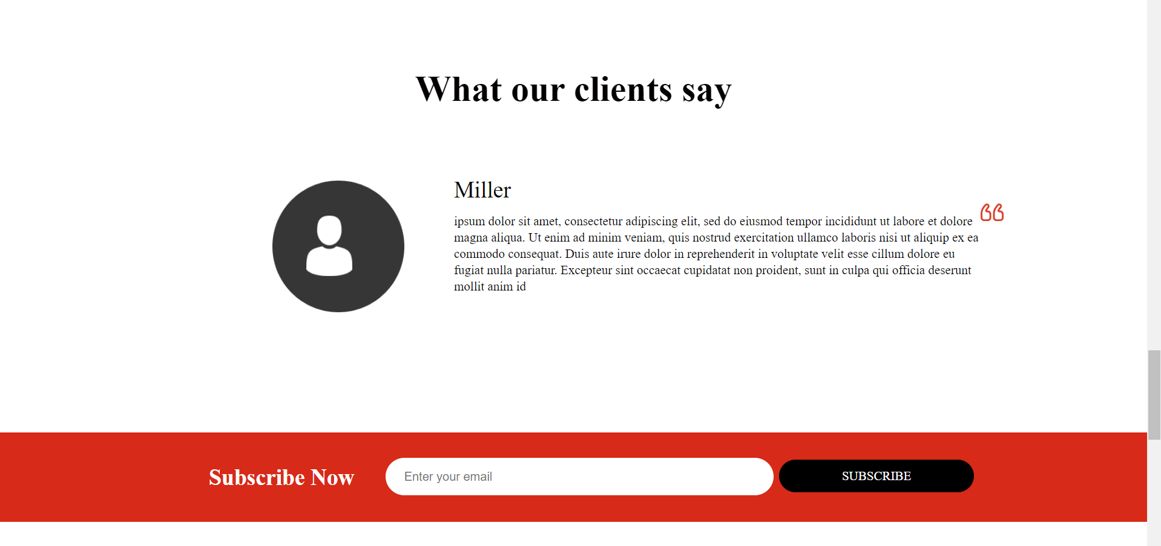

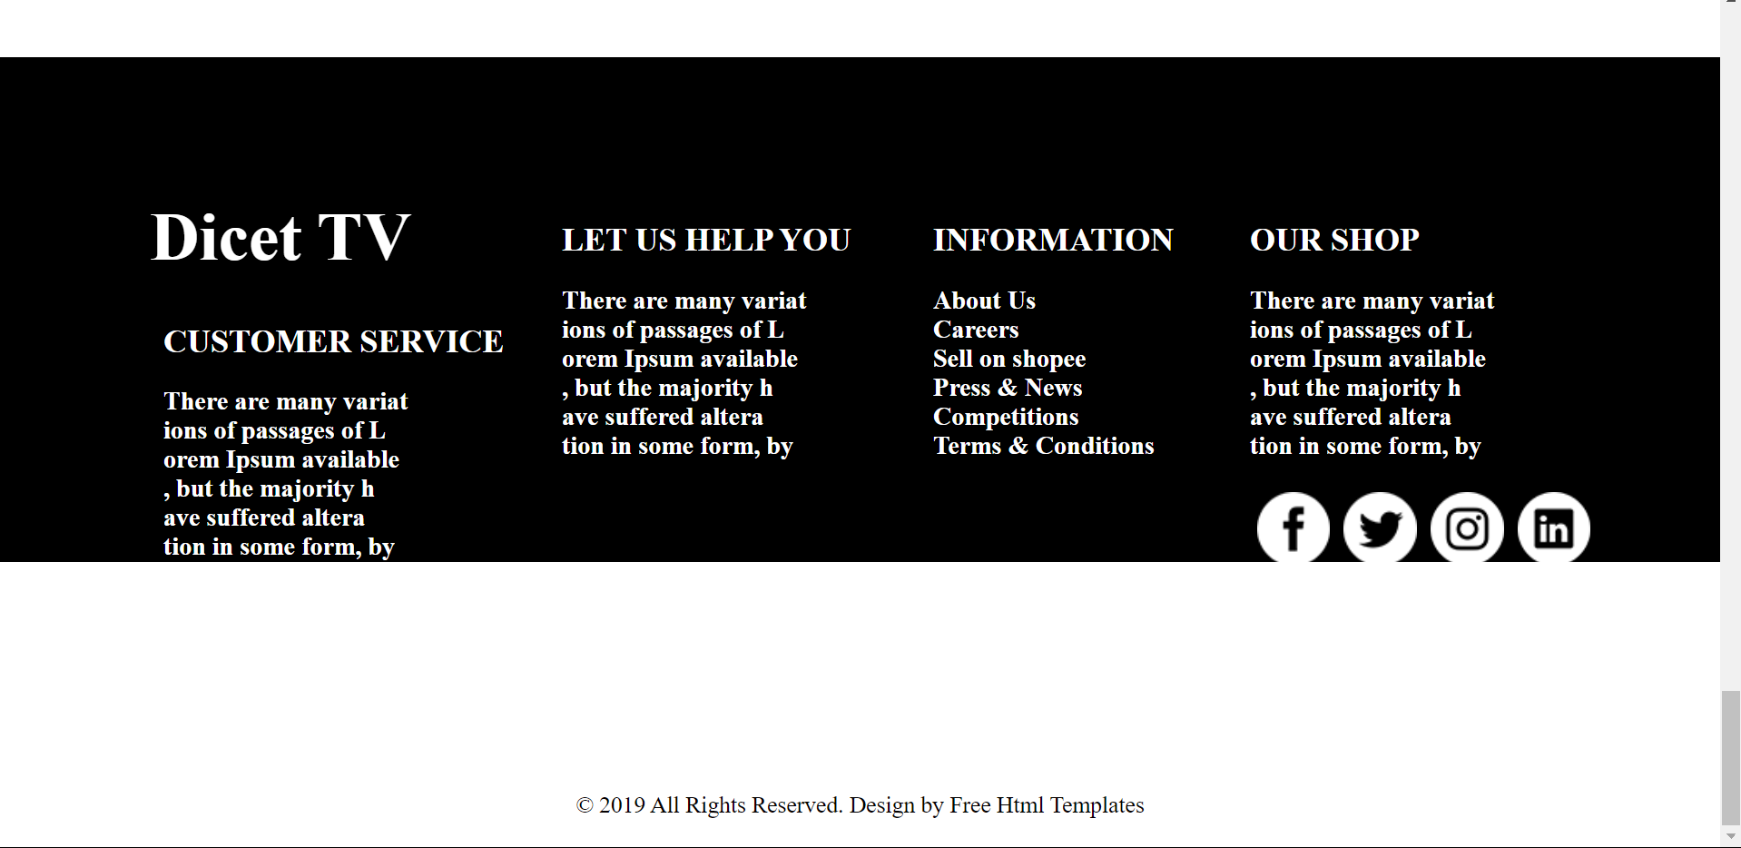

**Code:-**

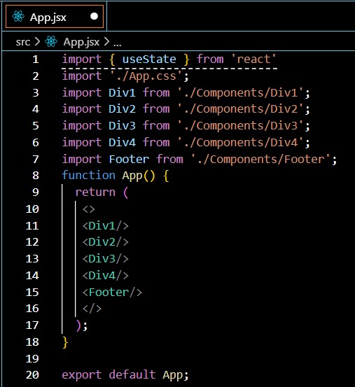

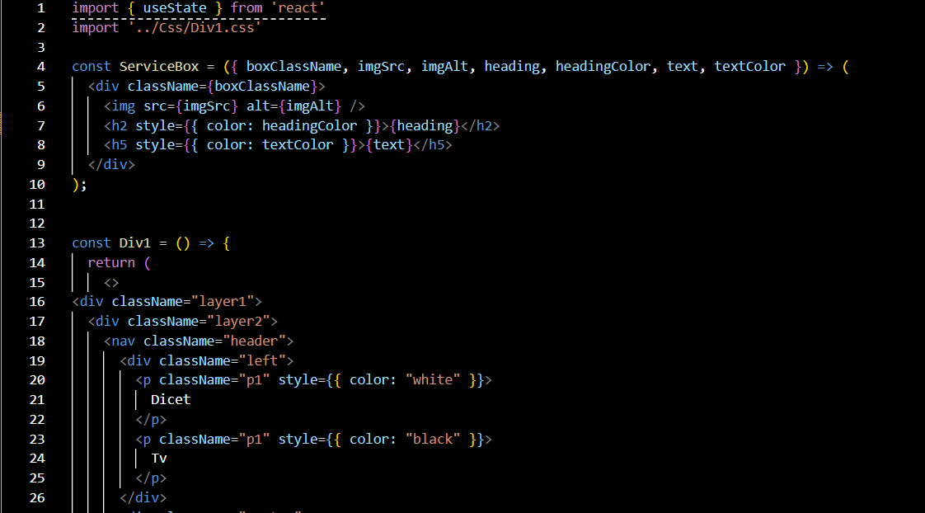

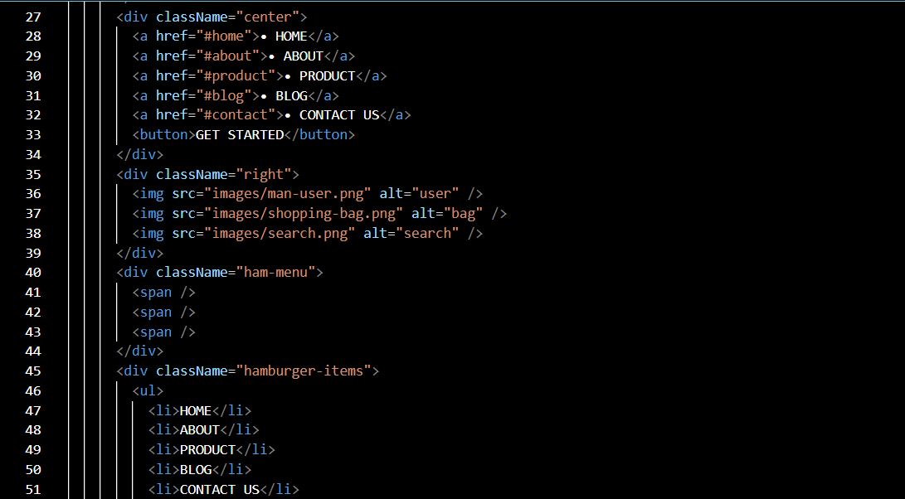

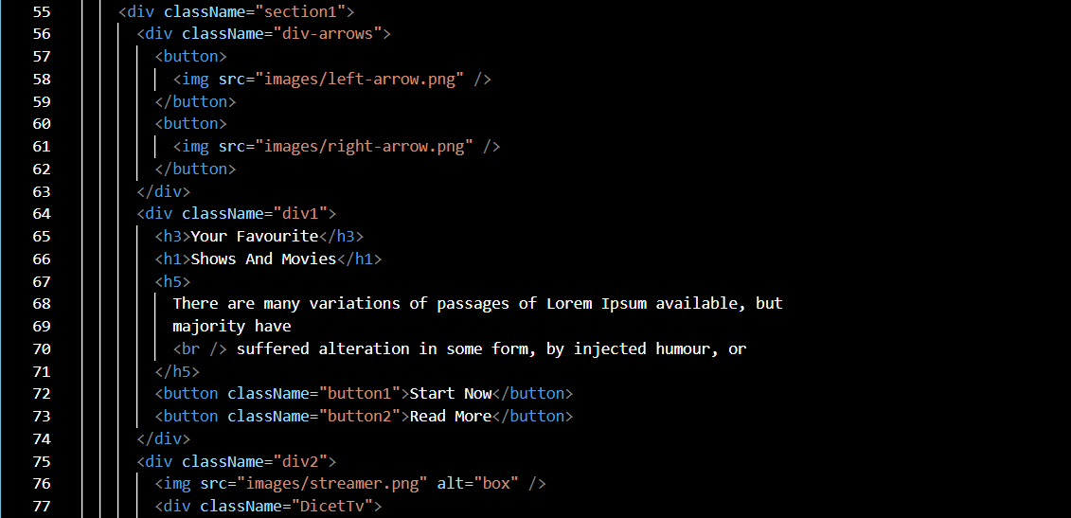

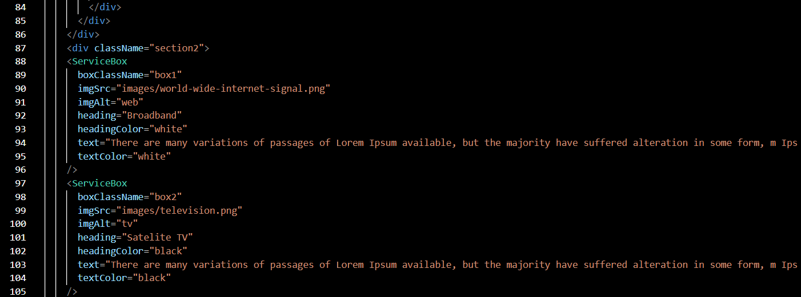

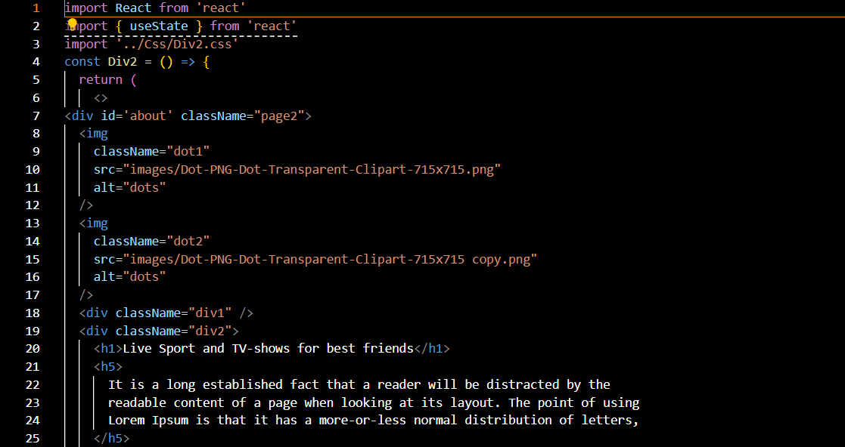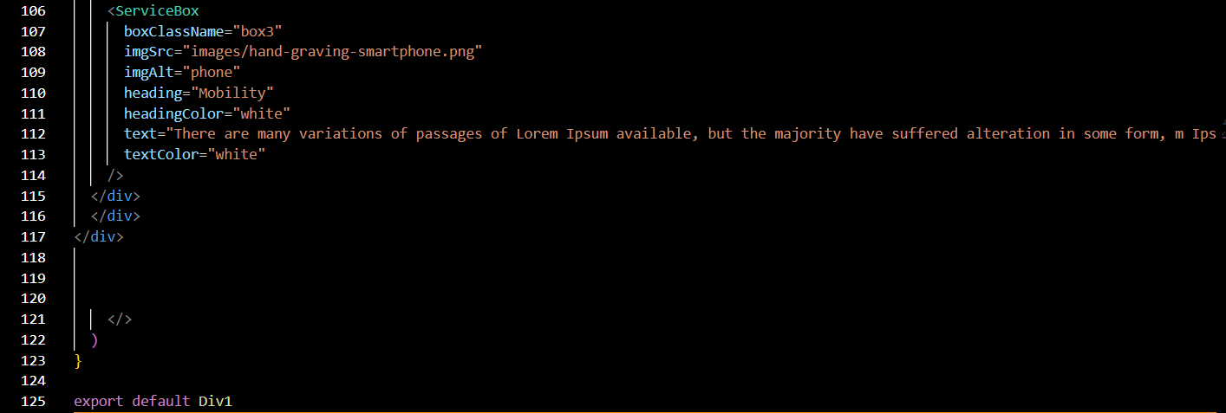

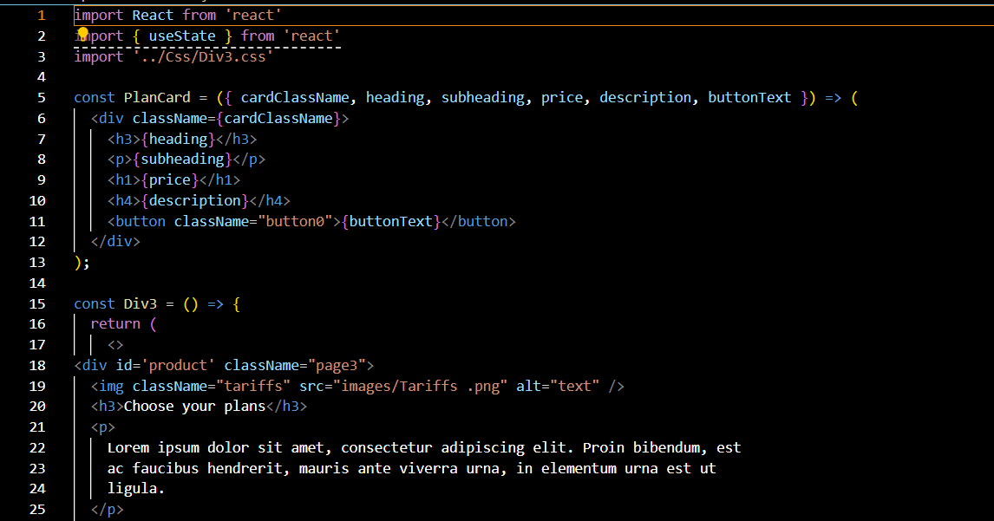

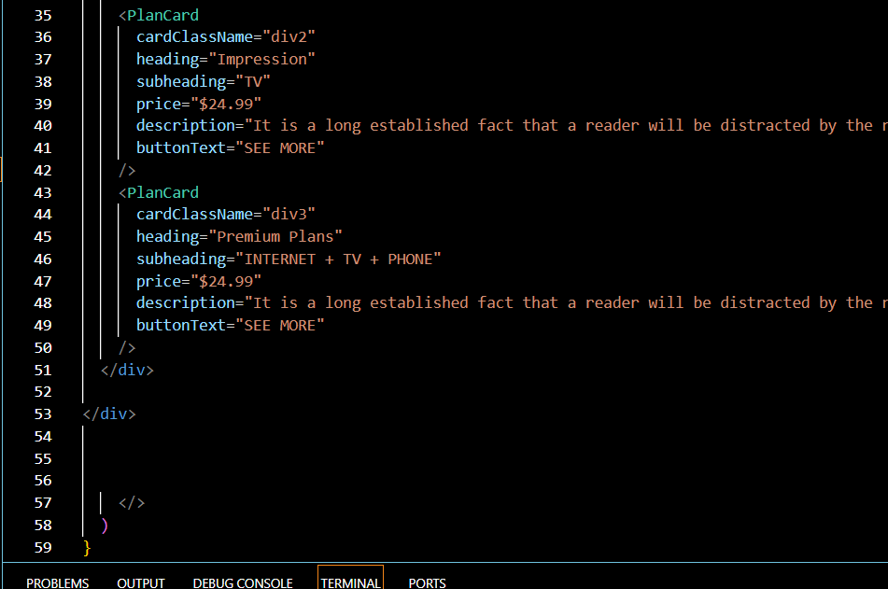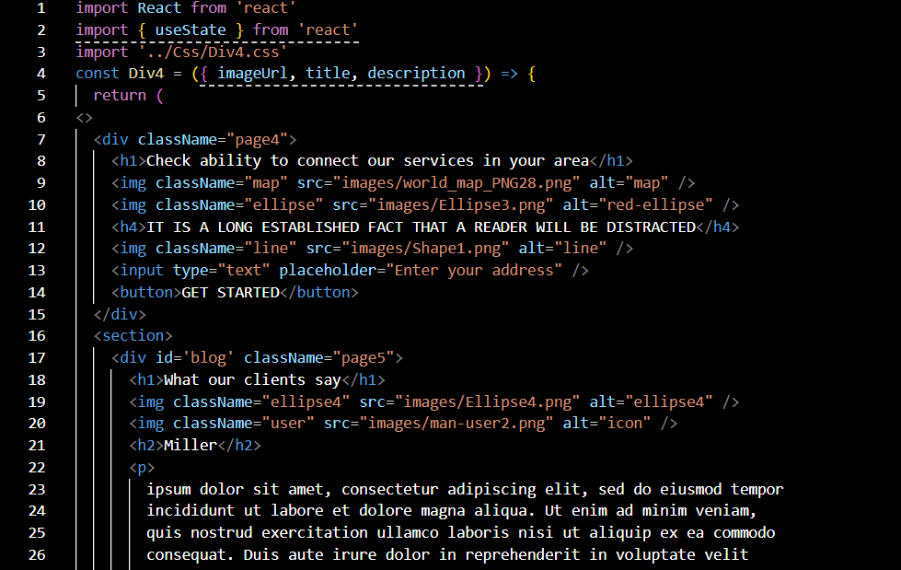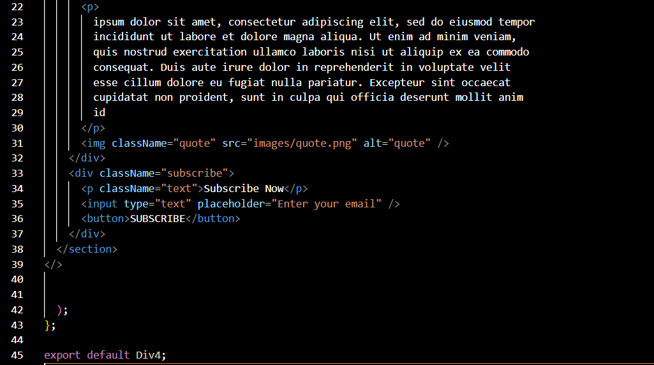

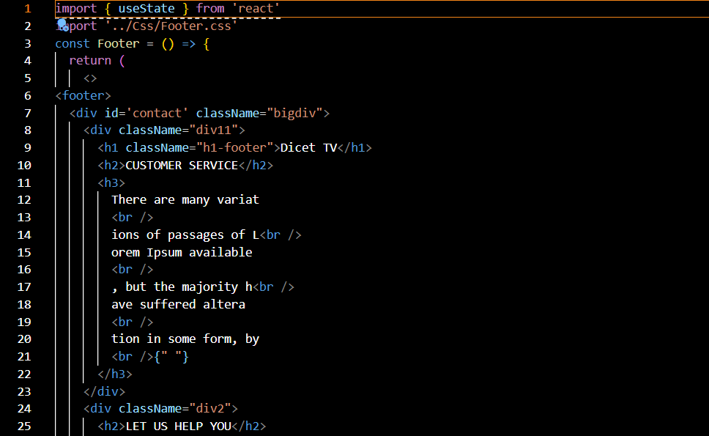

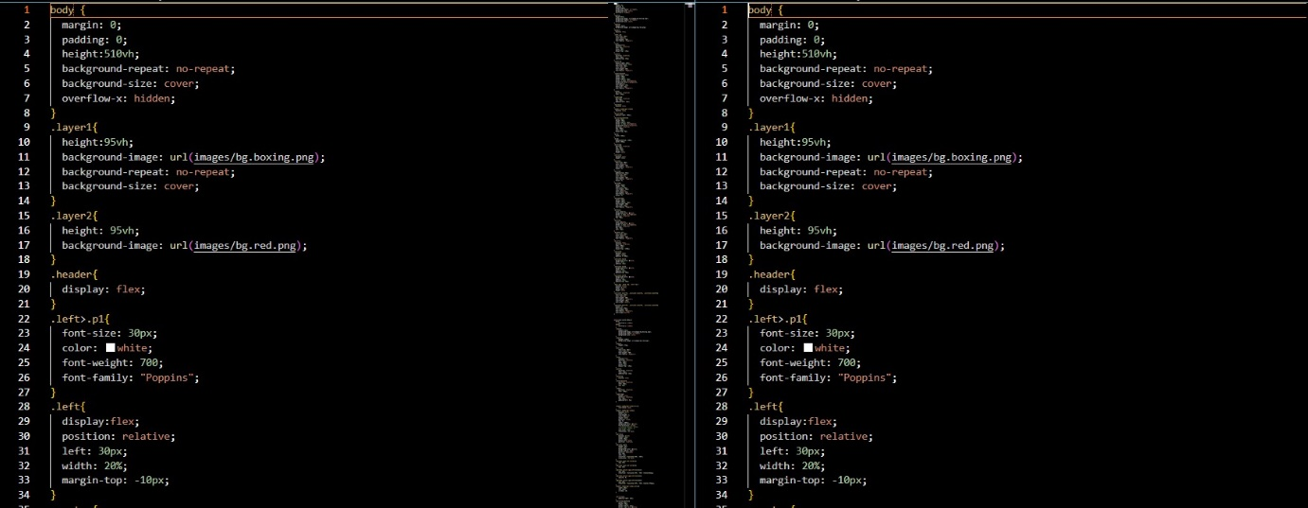

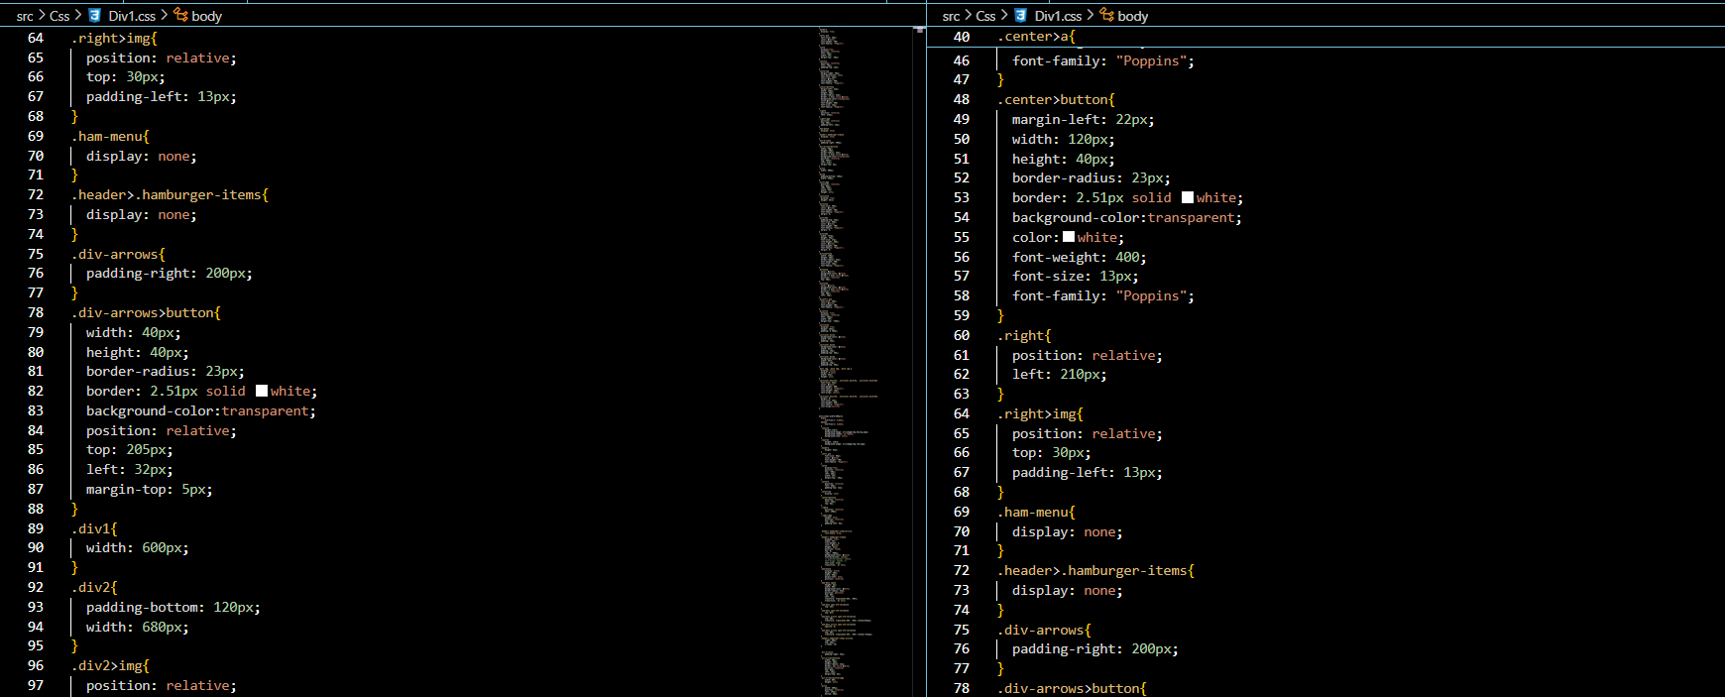

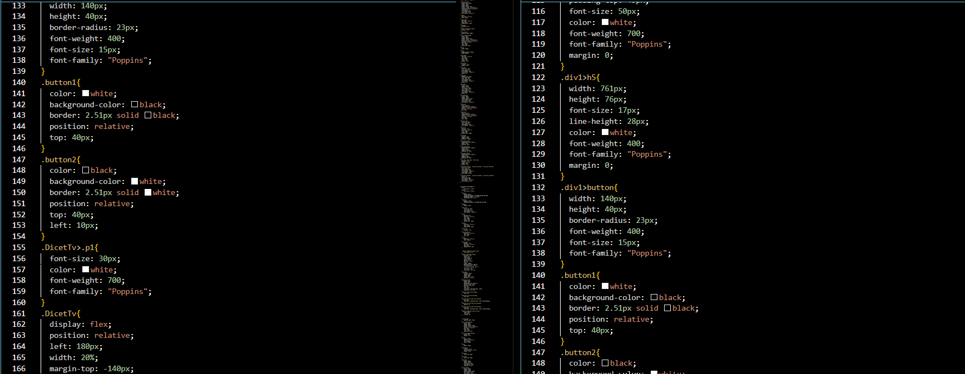

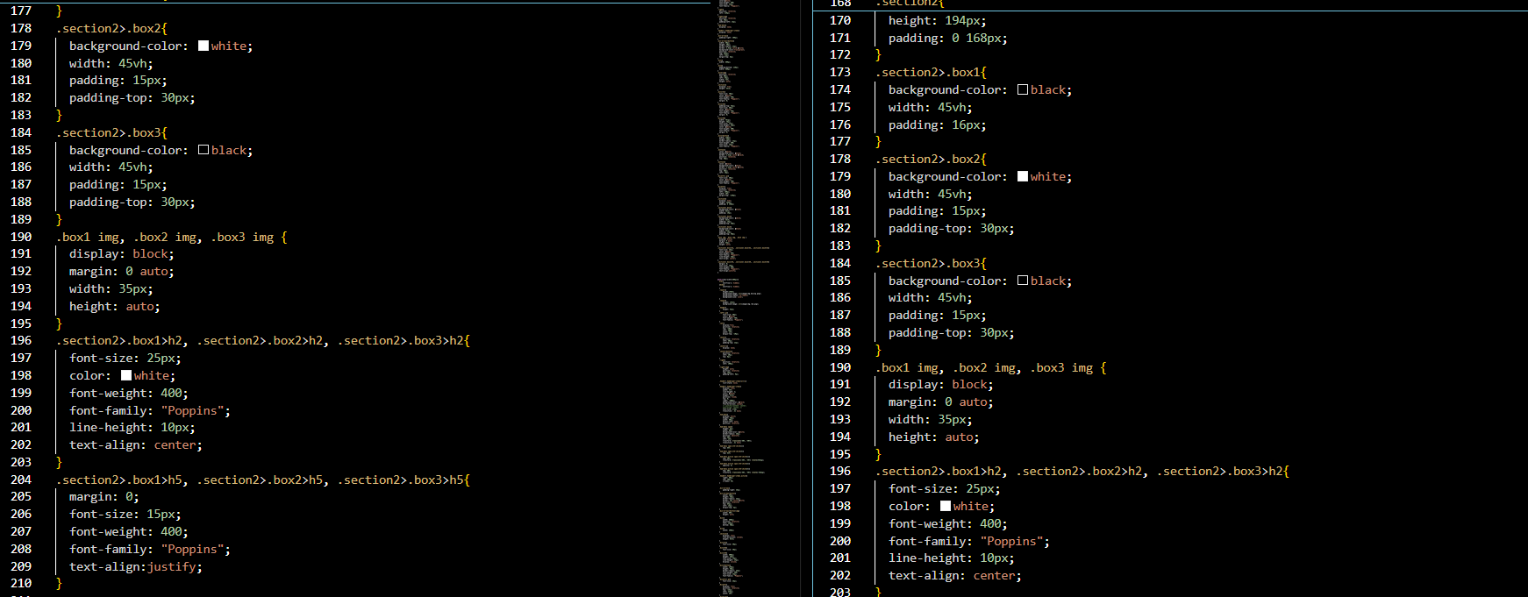

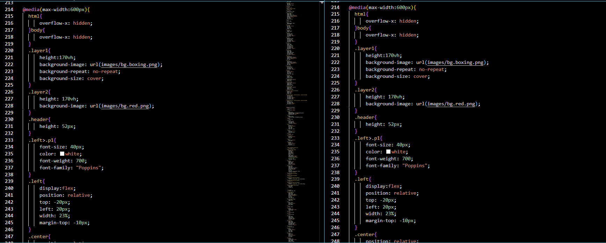

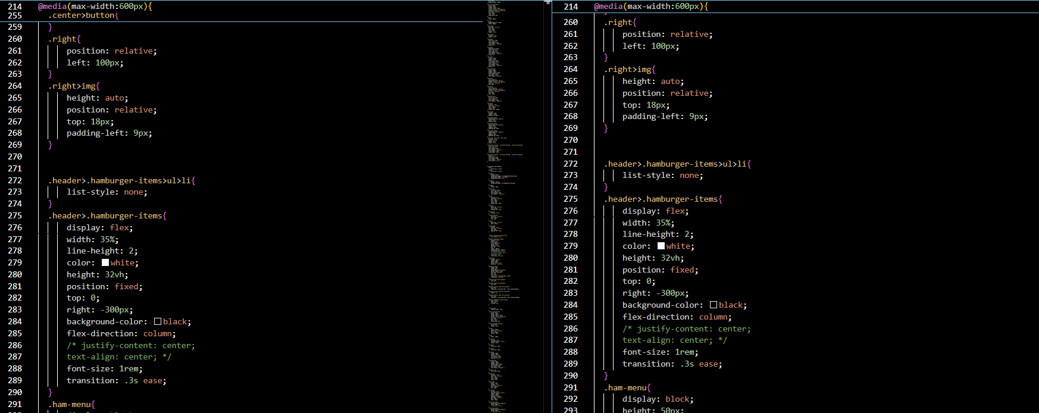

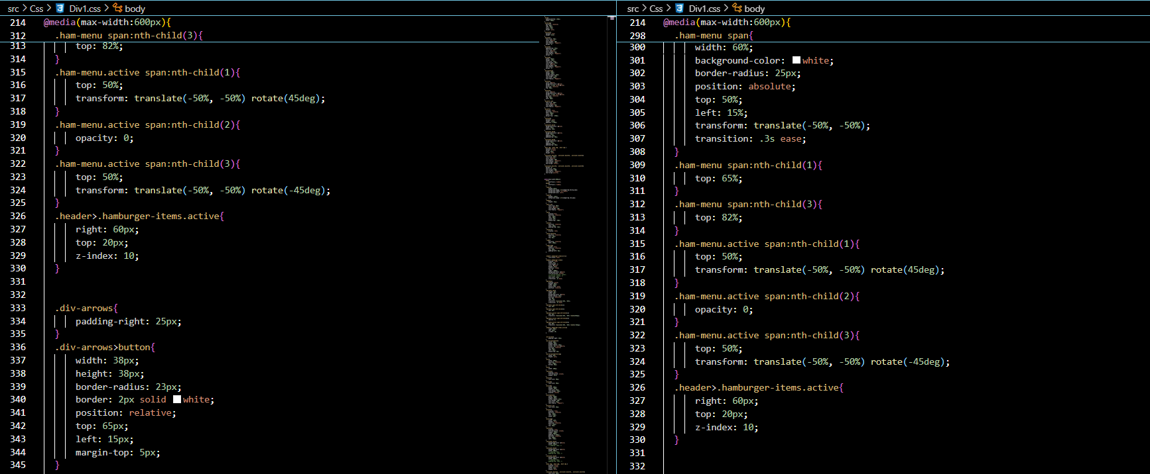

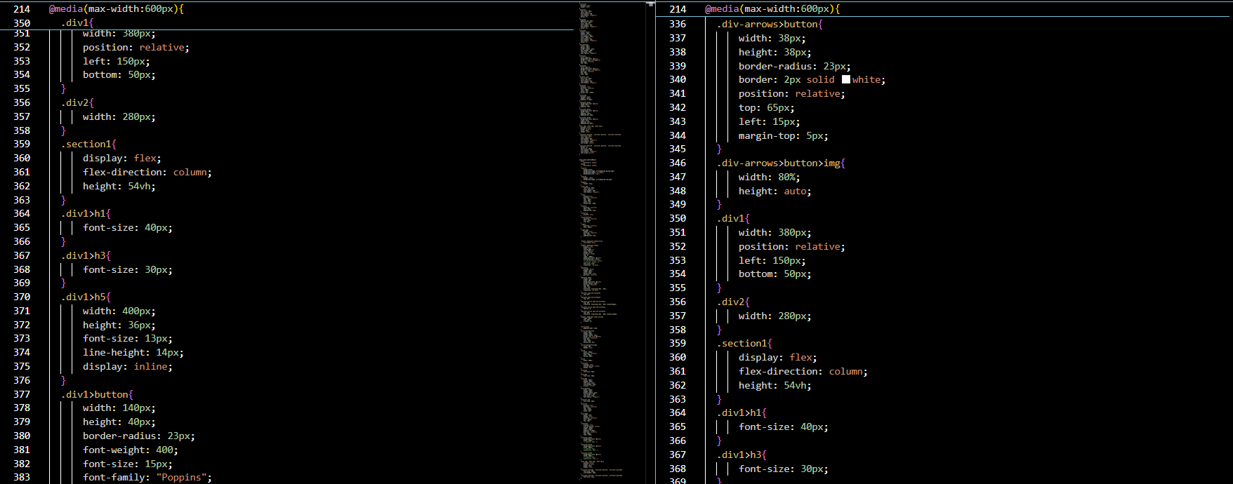

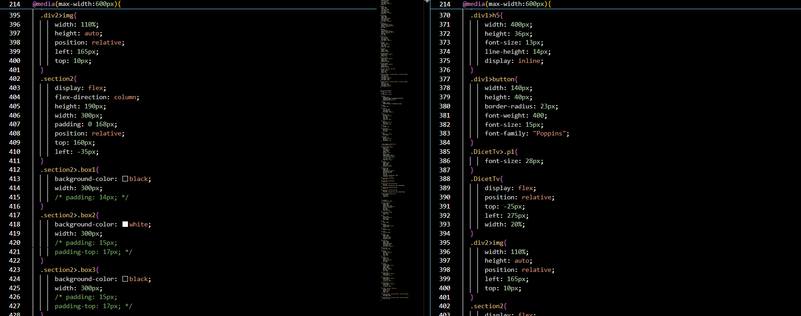

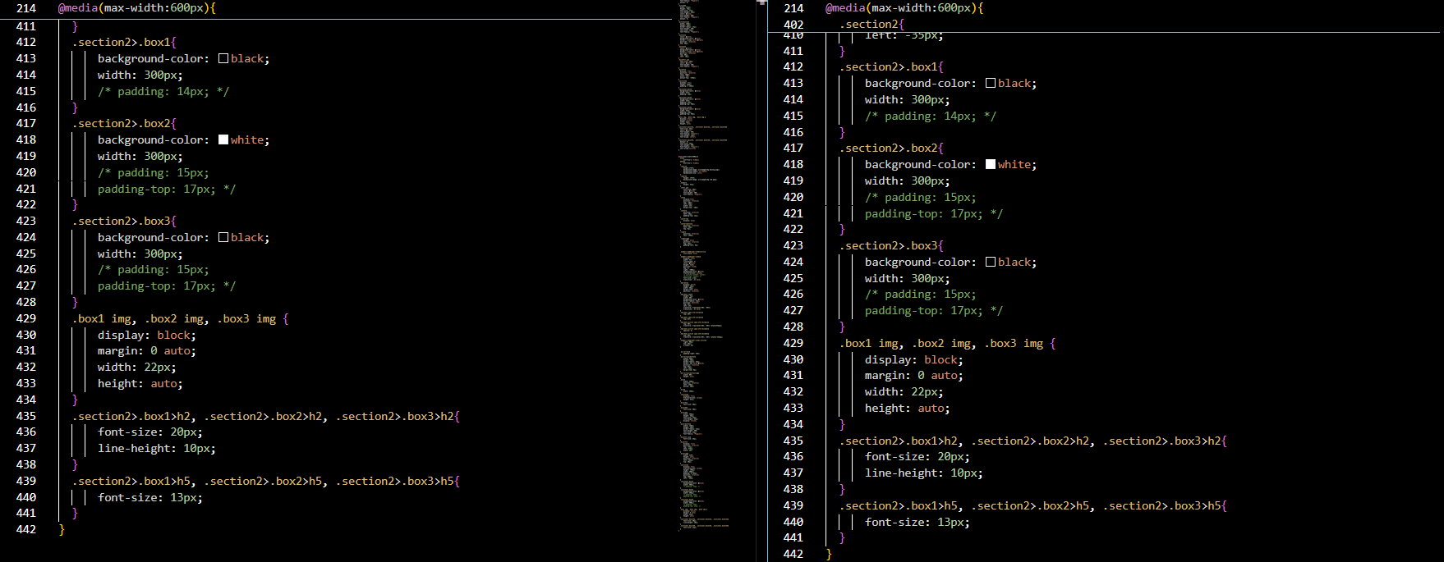

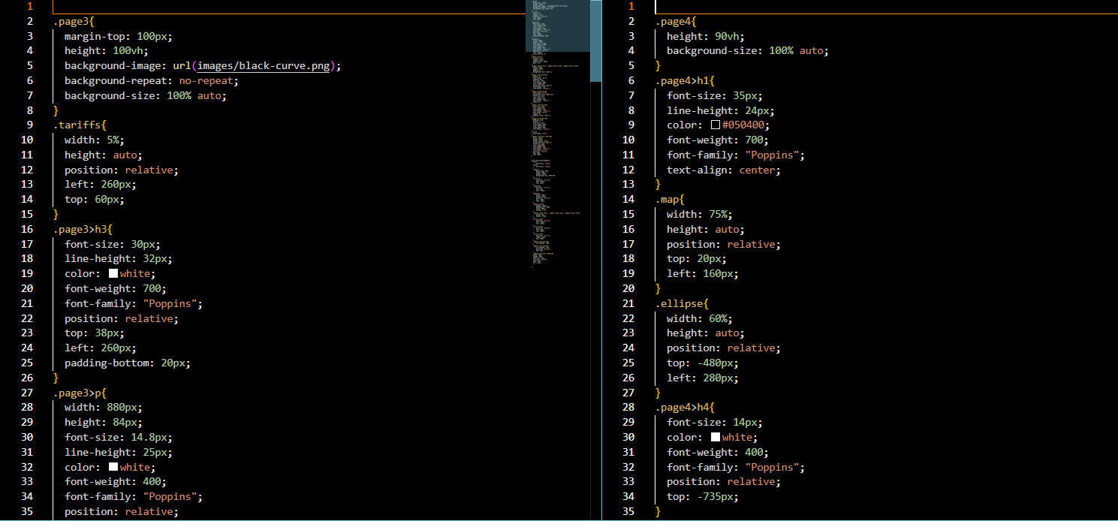

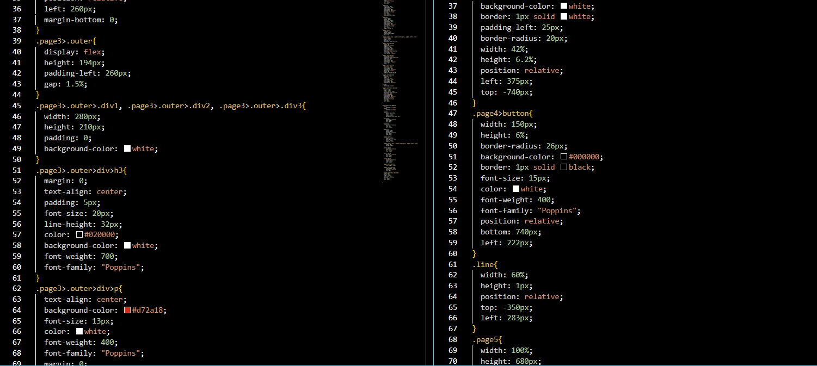

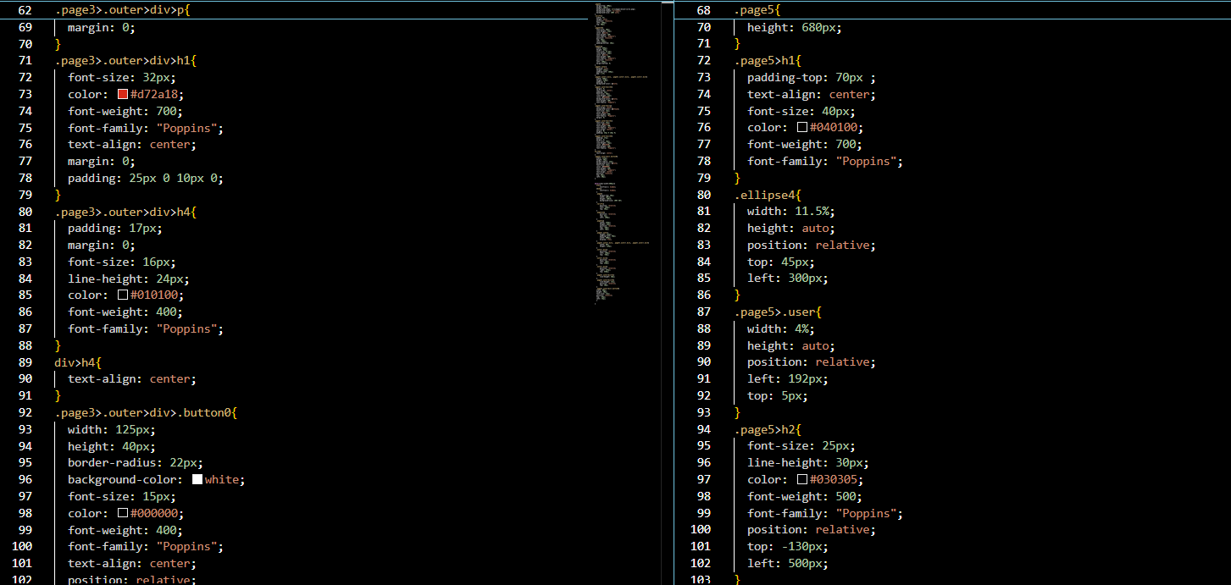

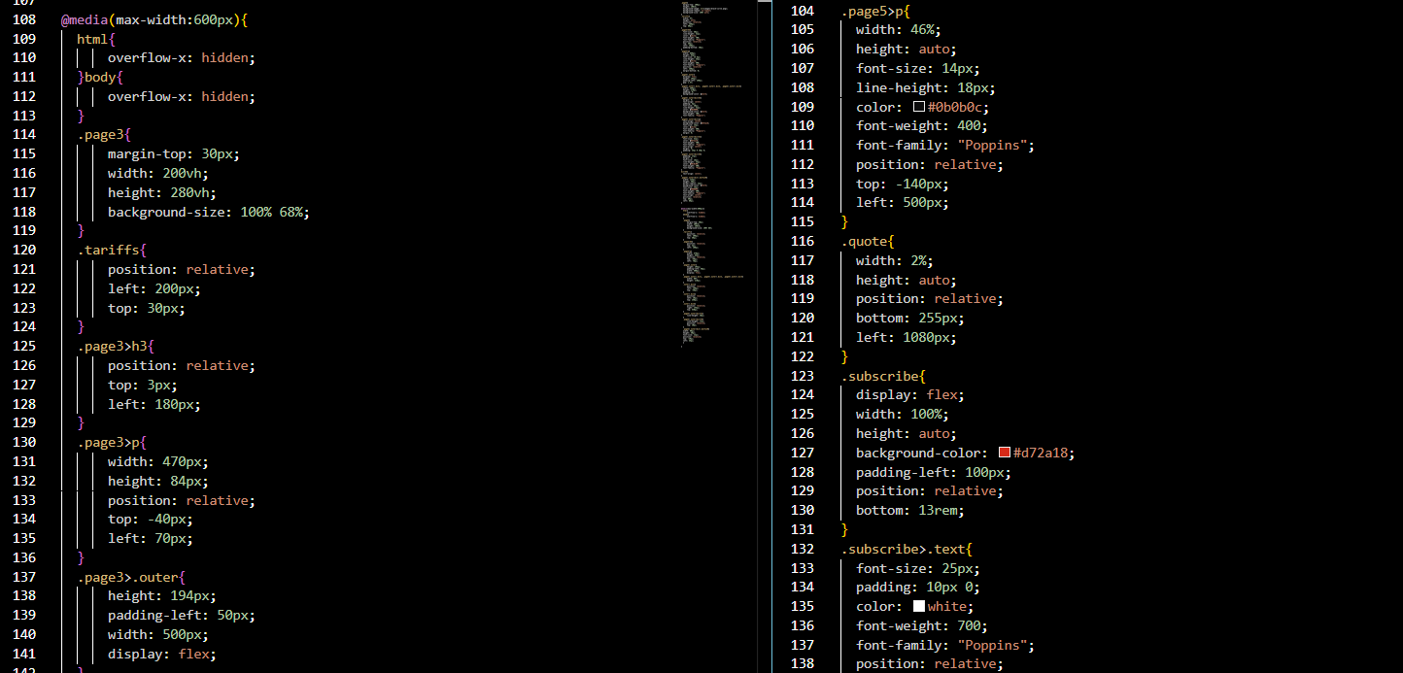

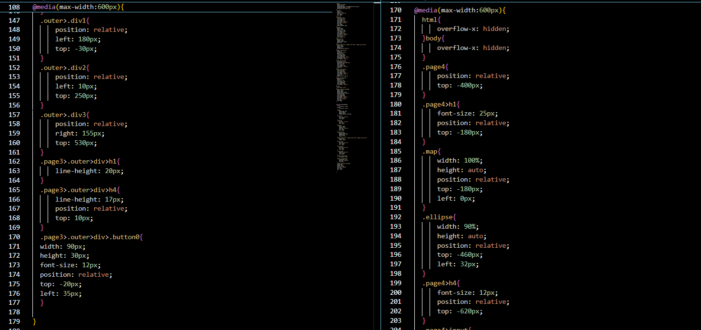

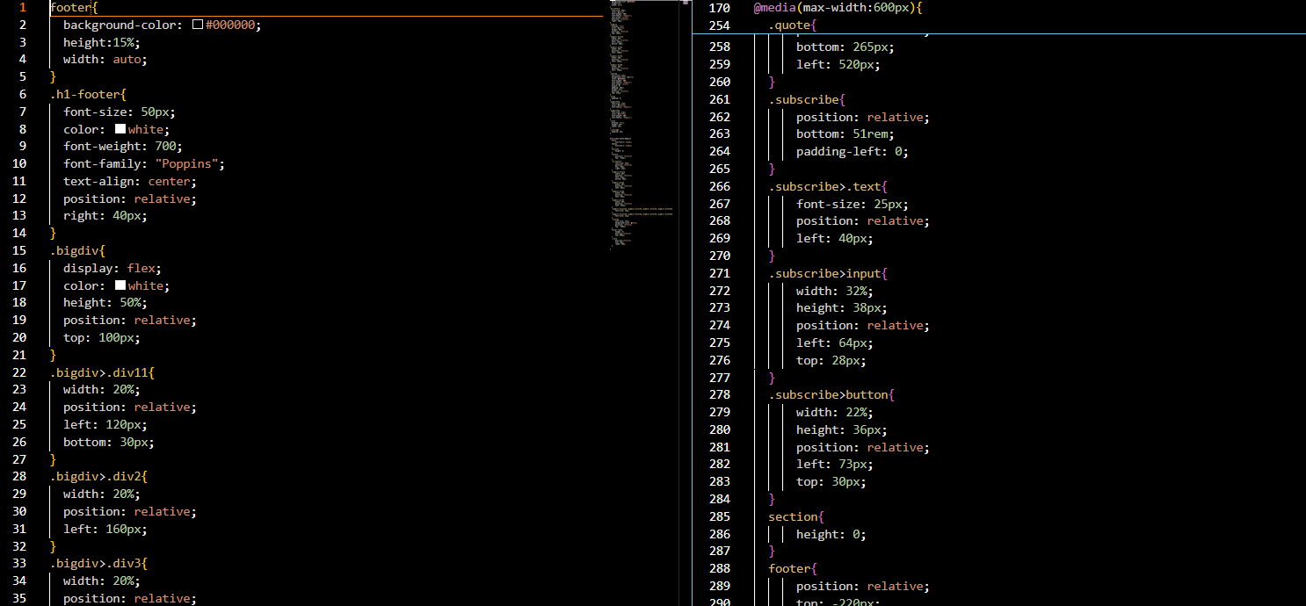

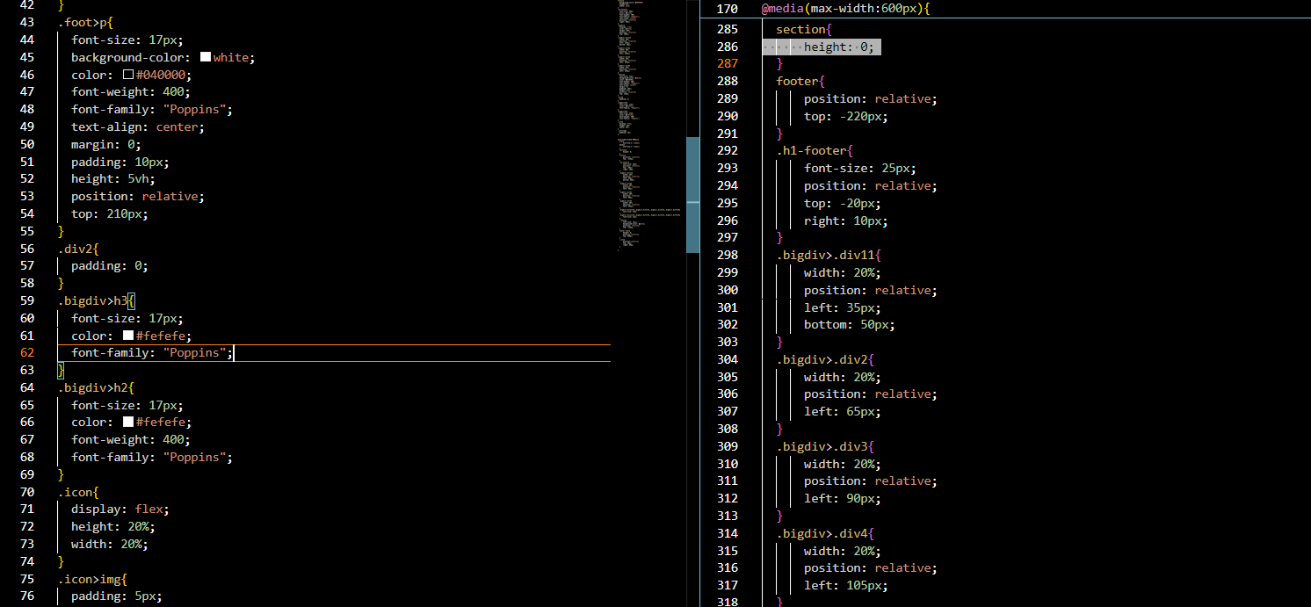

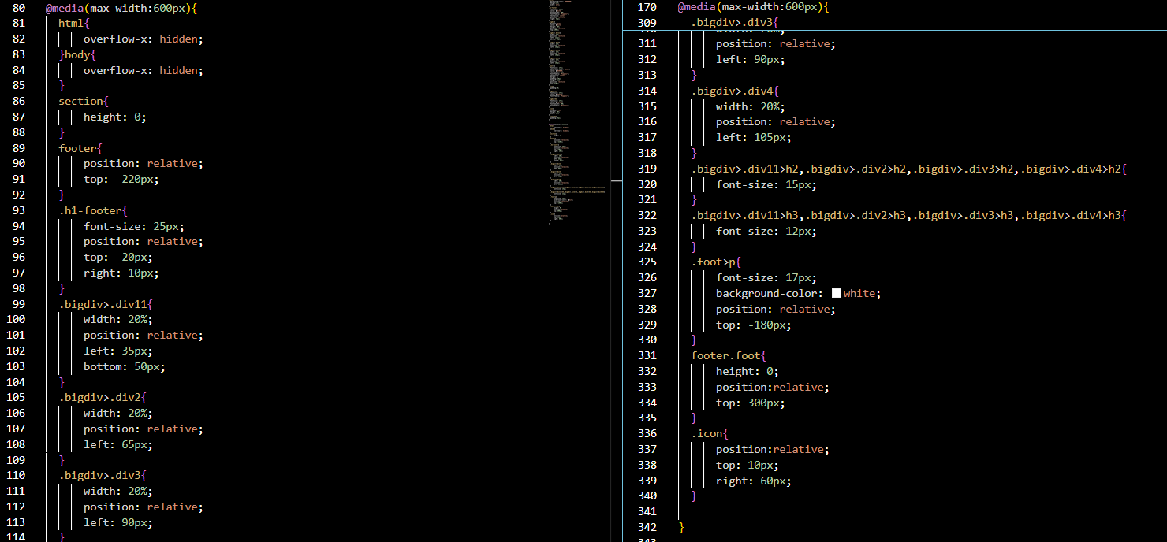

**REFERENCES**

1. [Photopea | Online Photo Editor](https://www.photopea.com/)
2. [www.w3schools.com](http://www.w3schools.com)
3. <https://fonts.google.com>